**Group 88 Work Minutes**

**Team Formation and Initial Setup**

Our group was formed on February 24th, 2024, and officially registered on the QMPLUS platform the following day, February 25th, 2024. The team consists of six members: Xinghan Li, Jiachen Hou, Simeng Lyu,Chang Liu, Junfeng Wang, and Jingyi Liang, with Xinghan Li serving as the team leader.

**Pre-Development Learning Phase**

From February 26th to March 3rd, 2024, the team focused on pre-development learning initiatives.

These included:

1. Gaining a thorough understanding of the group project's requirements and objectives

2. Reviewing Agile development methodologies to align our working practices with industry standards

3. Setting up the project's GitHub workspace to facilitate collaborative coding and version control

**First Weekly Meeting (March 3rd, 2024)**

The first weekly meeting was held on March 3rd, 2024, during which the following key actions and decisions were made:

**Task Allocation and Development Requirements**

1. The team leader clarified the overall project tasks and the requirements for the first development phase
2. The immediate focus was set on completing the product backlog and prototype documentation
3. This week's specific development task was defined as writing user stories for the product backlog

**User Story Writing Guidelines**

1. Each team member was assigned to conduct market research and complete at least three high-quality user stories
2. The user stories were required to not only cover the essential functions specified in the project requirements but also explore extended functionalities to enhance product value

**Training and Tool Selection**

1. The team leader conducted a training session to refresh everyone's memory on user story writing formats and criteria
2. Trello was selected as the platform for writing the backlog, and Fliplet was chosen for creating the prototype
3. The team leader provided guidance on how to effectively use Trello for our backlog management

**Meeting Atmosphere and Team Building**

1. The meeting had a lively and collaborative atmosphere with active participation and consensus-building among all members
2. To strengthen team cohesion and interpersonal relationships, a series of ice-breaking games were organized after the meeting

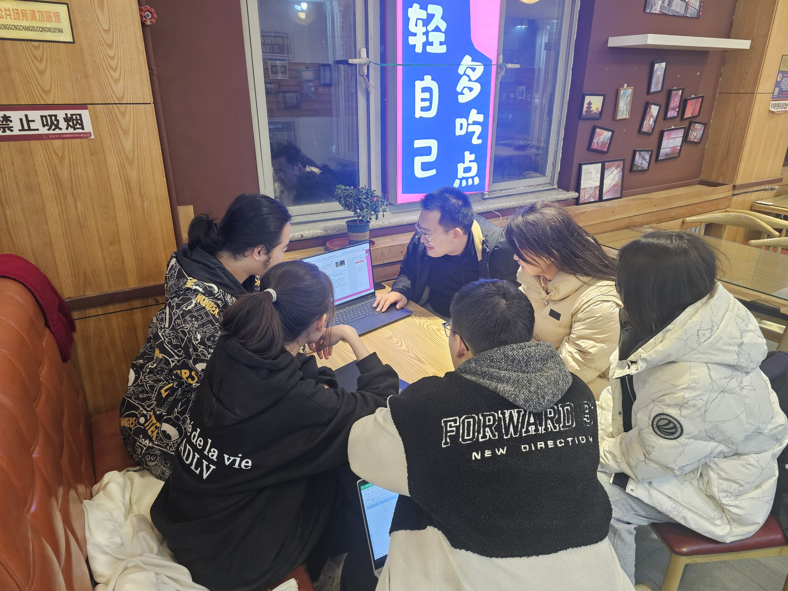

Fig.1|Scene of the first weekly meeting of the group 88

**Second Weekly Meeting (March 10th, 2024)**

The second weekly meeting was scheduled to be held on March 10th, 2024.